**AUDIT COURSE**

**ELECTRONIC CIRCUITS 1: SIMULATION BASED STUDY**

**LAB 5**

Kindly update your name and roll no, once this document is shared with you

Time slot to complete your work is **40 MINUTES**

**Date: 17/8/2020**

Kindly upload your schematic & waveform images here, every 10 minutes, indicating your progress and intention to completion of WORK within time slot allotted

**Time slot allotted to you all for the completion of WEEK 3 DAY 1 is 40 MINUTES**

**Kindly upload your work (only circuit schematic & waveform in LTSpice) in the shared google doc between this time slot only.**

**Follow these instruction strictly:**

1, Start sharp ON TIME, by posting your name and roll no and **screenshot of your LT spice work screen ( time and date MUST BE VISIBLE)**

2. Upload your work every 10 minutes, i.e LT spice work screen

3. This means you will upload LT spice work screen 4 times during this time slot.

4. Point 3 indicates your readiness and presences for completion of WEEK 3 DAY 1

**You are entitled for 1 CREDIT per Lab only if you follow above instruction to the details**

**STUDENTS WORK AREA STARTS HERE**

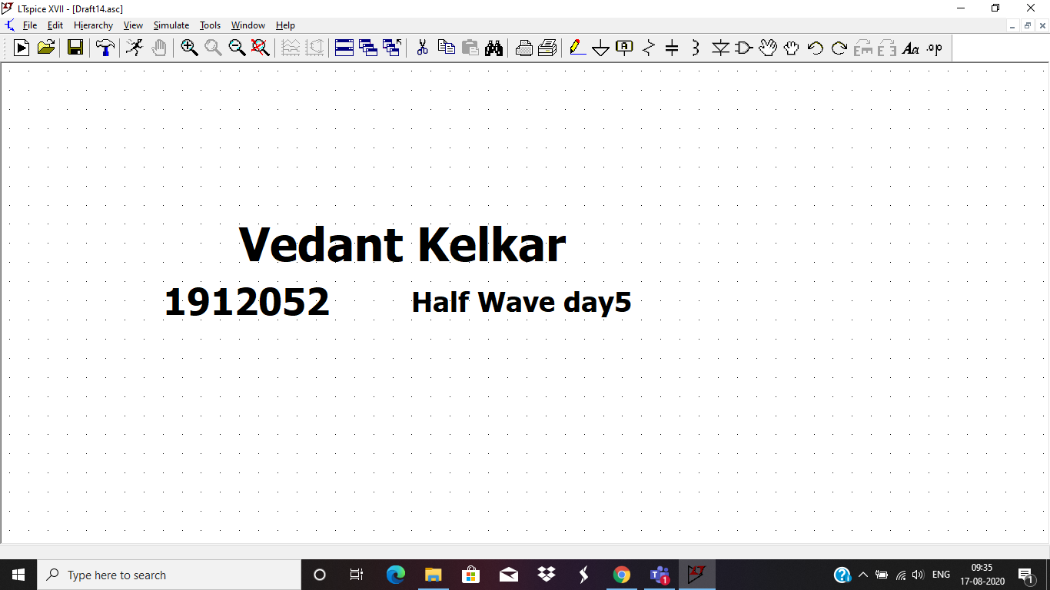

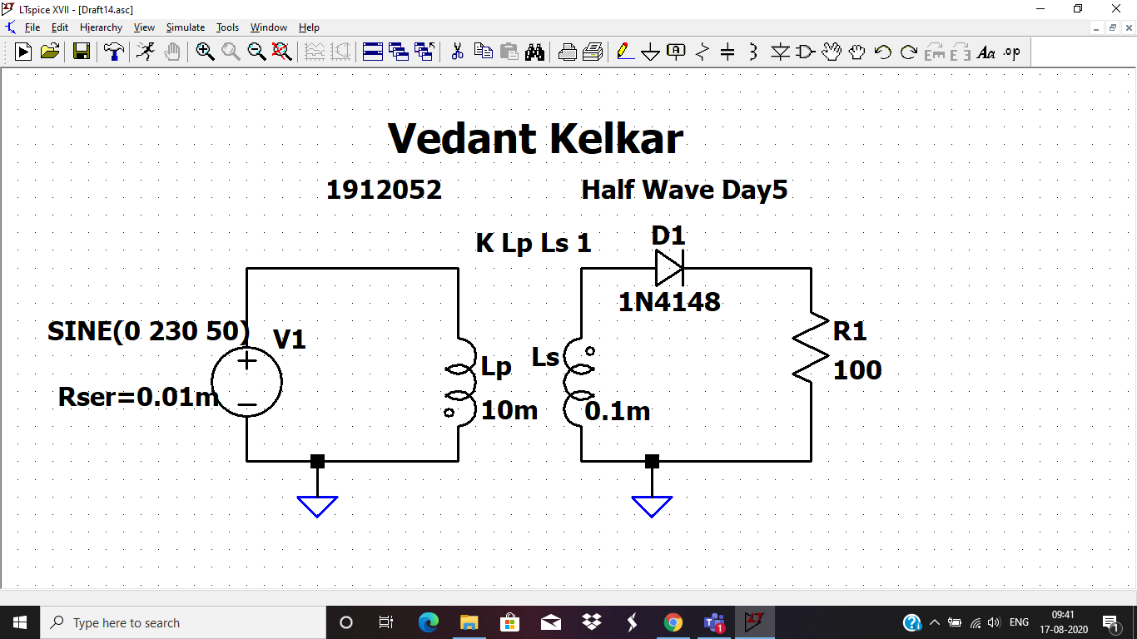

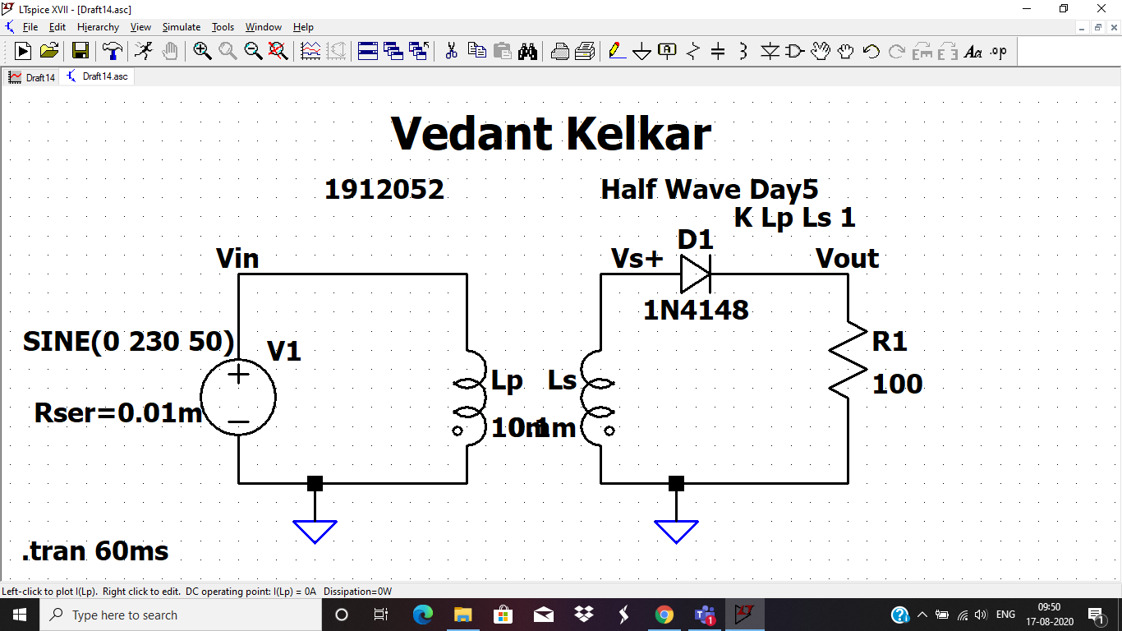

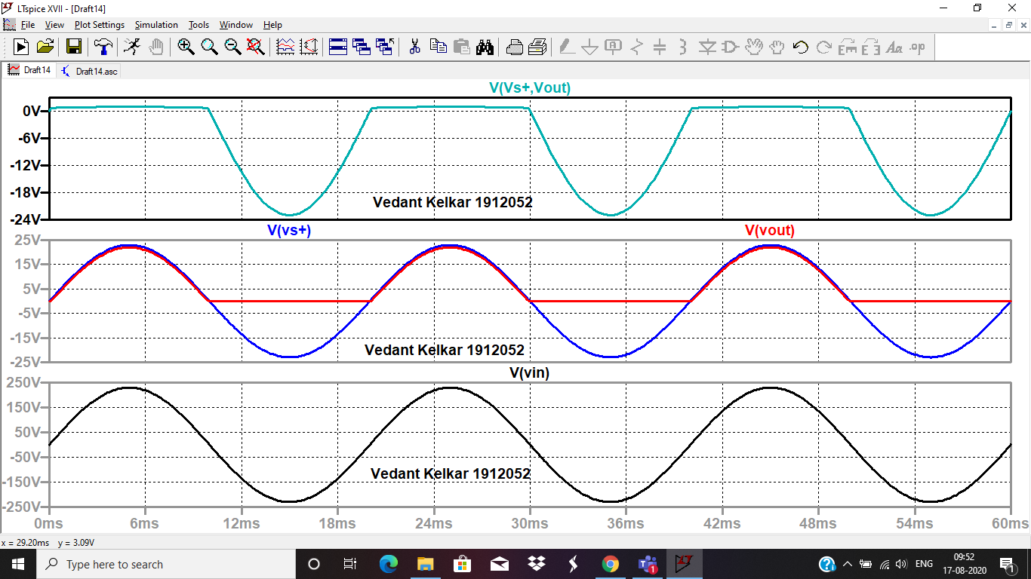

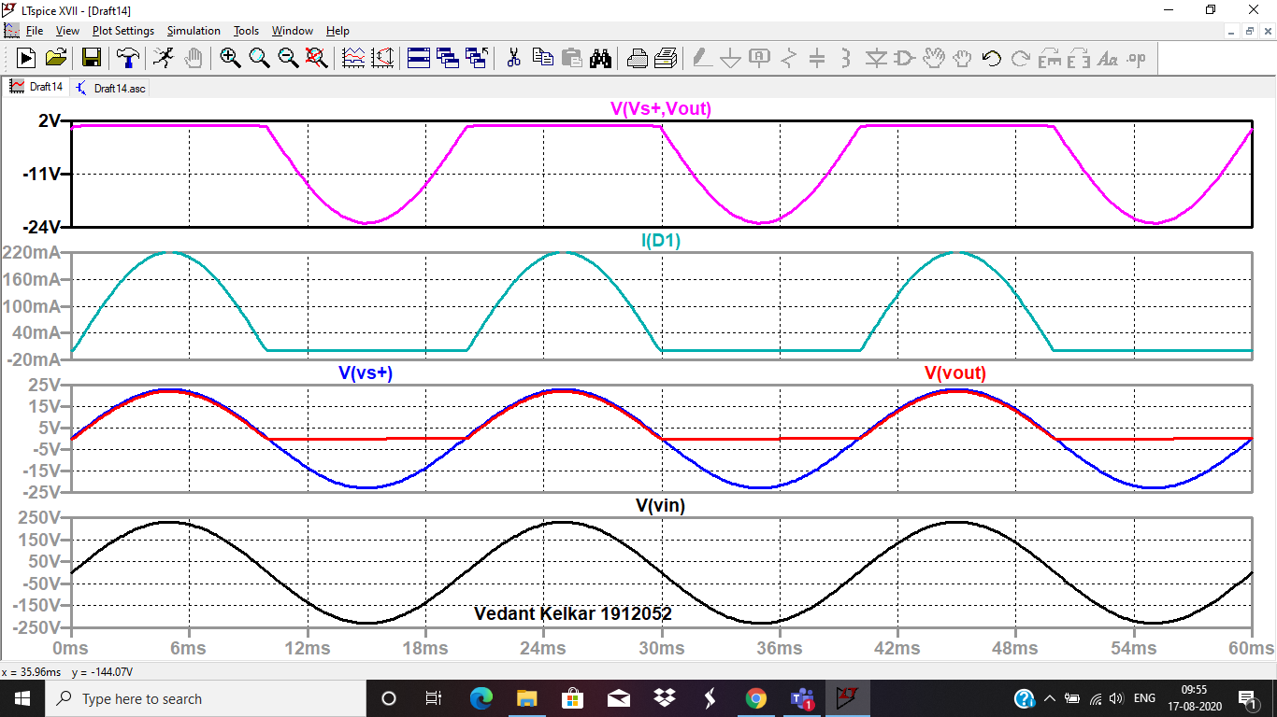

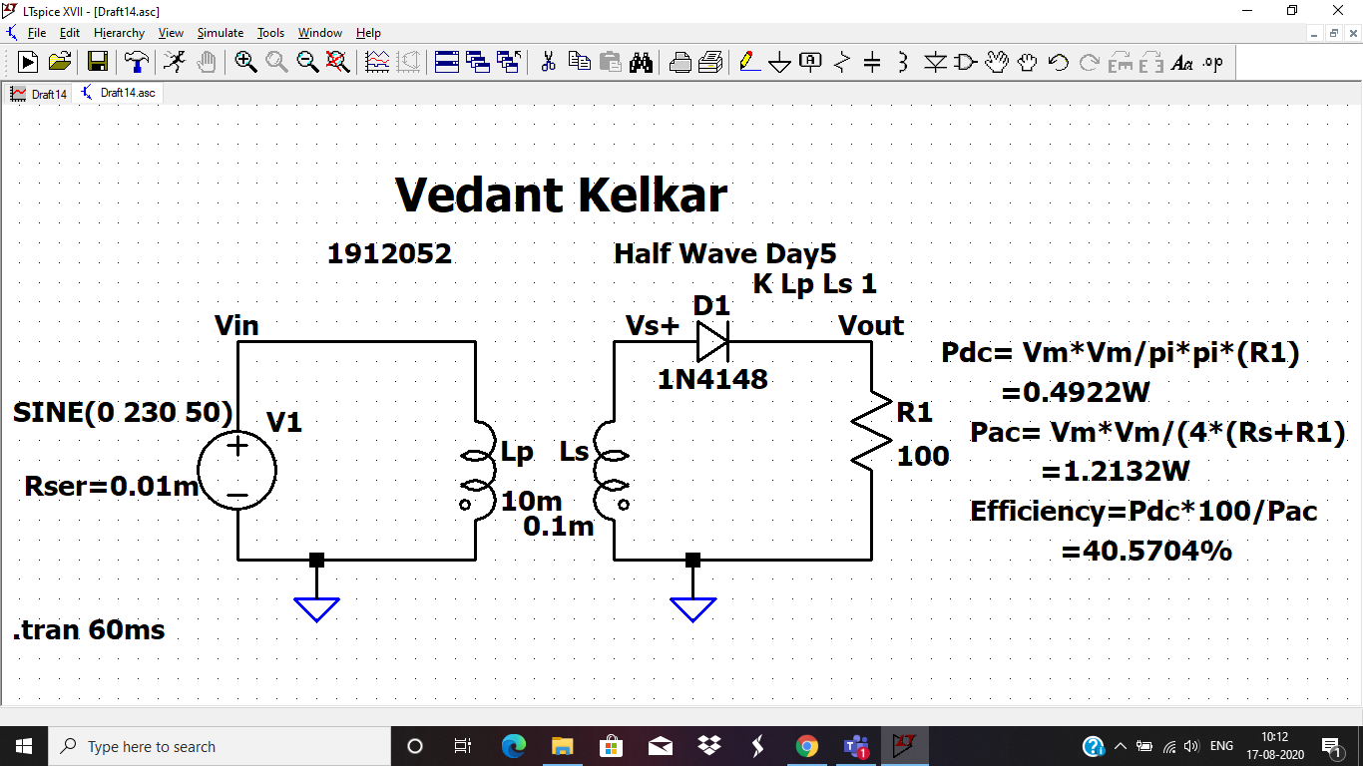

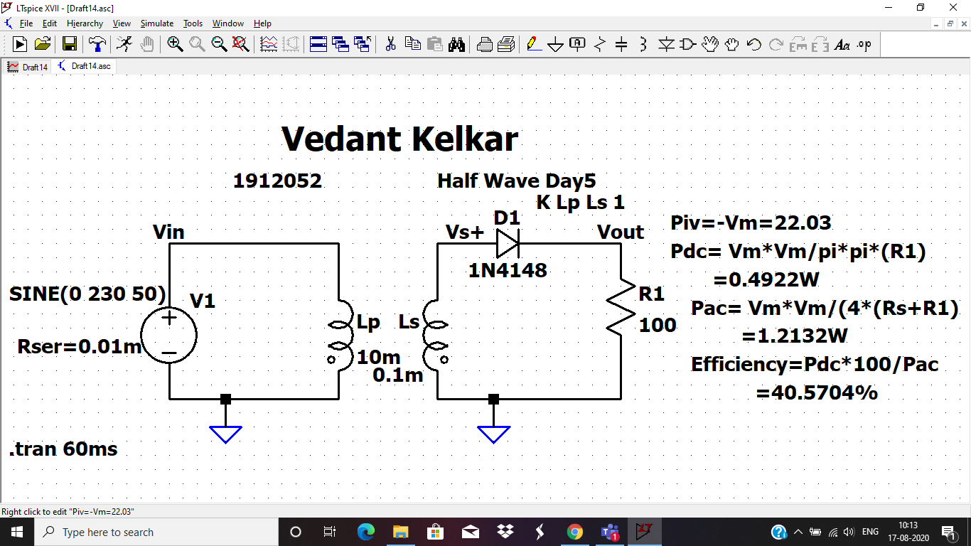

**PIV rating of diode D1 is 22.03 V**

**Efficiency =40.5704%**

**Pac = 1.2132W**

**Pdc = 0.4922W**

**LAB 5 is approved: Inderjit Singh Dhanjal**

**Attach these images in LAB 6**

